Charles Leung – 400049422 – leungt11

**ENGPHYS 3BB4**

**ELECTRONICS II**

**LAB 5 REPORT**

Simple Oscilloscope using TI MSP-430

**ABSTRACT**

The objective of the 5-week Design Project is to design an ultrasonic rangefinder using digital and analog components available in the electronics laboratory. The objective of the ultrasonic rangefinder is to digitally display a distance measurement in centimeters on a 7-segment-display by measuring the propagation time (time of flight) of an ultrasonic burst. The ultrasonic burst is to be emitted by a piezoelectric transducer (transmitter), while another piezoelectric transducer (receiver) serves as a microphone to pick up the reflected signal. The distance can then be determined by using the propagation time and the known velocity of sound in air to produce a distance quantity using the relation distance = speed $×$ time. The target range and resolution of the rangefinder is 10 to 99 cm ± 1cm.

The final implementation did not perform as expected, however detailed testing showed that the majority of the components were functioning nominally on their own. The author believes that the implementation was very close to working and the cause of the issue was a small technical oversight between the latch output and the reset function of the timer.

**INTRODUCTION AND THEORY**

**Abstract**

**Introduction**

Lab 5 aims to consolidate and make use of the electronic theories and laboratory work with the Texas Instruments MSP430 microcontroller over the duration of the course so far to create a simple oscilloscope. The aim is to feed an analogue electronic signal through the function generator of the Hantek device into the receiving port of the MSP430, where it is analyzed by the Analogue-to-Digital-Coverter (ADC) module. The ADC then transmits the digital data to a computer which outputs a digital waveform through a MATLAB plotting tool, allowing the user to visualize the approximate shape of the signal. There are several techniques used in prior labs that perform critical functions that allow the oscilloscope to function. These techniques include:

* Configuration of the onboard clock and baud rate settings
* Setting input and output ports in anticipation of establishing UART serial communication
* Writing a C program to transmit data from the MSP430
* Writing a MATLAB program to receive data on the PC
* Outputting results on a digital plot via MATLAB
* Demonstrating the Nyquist theorem and aliasing phenomena

**Theory**

This section explains some of the techniques listed in the Introduction in greater detail.

**Comparator & Analogue-to-Digital-Converter Module**

The MSP430 contains an onboard 10-bit Analogue-to-Digital-Converter (ADC) Module. As the name implies, this module provides means of digitizing an analogue input signal so that it can be turned into discrete data that can be operated on by the microcontroller. This functionality is crucial for the microcontroller to be able to output a sampled waveform for display in MATLAB.

**Nyquist-Shannon Sampling Theorem**

Sampling is a process of converting a continuous signal into a sequence of values taken across a regular interval. The frequency of which the samples are taken is known as the sampling rate.

The Nyquist theorem describes a curious phenomenon: the samples of sine waves can be identical when at least one of them is at a frequency above half the sample rate. This establishes a lower bound for a reliable sampling frequency based on what the frequency of the input signal is known to be, and any sampled input signal that is above this sampling frequency may not be an accurate representation of what the actual input waveform is supposed to look like in reality.

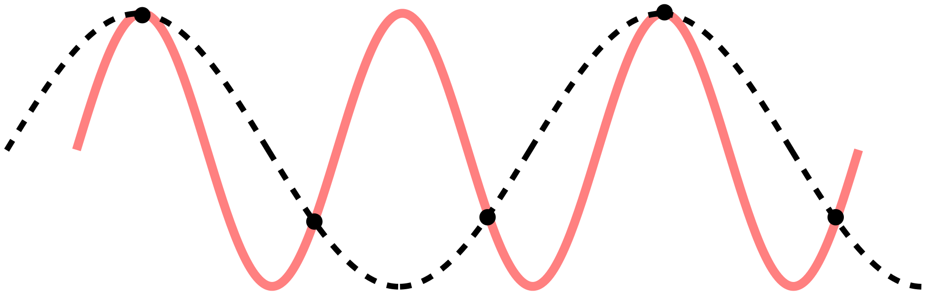

The pink waveform has a frequency double that of the sampling rate. Its image will be an *alias* of a waveform with equal frequency to the sampling rate.

**Block diagram**

Fig. 1 is the block diagram of the circuit that was decided to be the best implantation of the project following the design and planning stage.

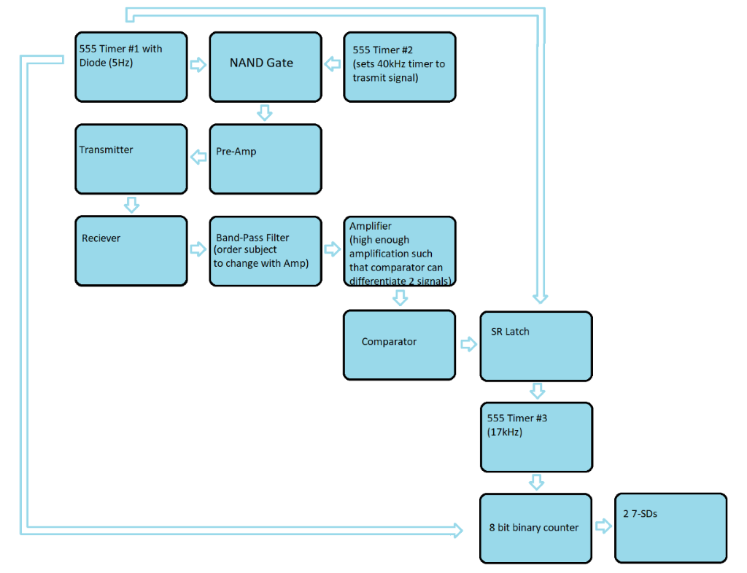

**Figure 1:** High-level block diagram of the ultrasonic rangefinder circuit.

After the design and discussion process, Fig. 1 is what our group settled on for our implementation. We had 3 555 timers sending the clock signals of 2.5 Hz, 40 kHz and 17 kHz respectively. The 2.5 Hz timer established the refresh rate and pulse envelope, the 40 kHz timer drives the transducer, and the 17 kHz timer drives the counter circuit.

The transmitting transducer outputs the 40 kHz signal, which travels to the surface of the object whose distance from the sensor is to be measured. The receiving transducer receives this signal and outputs an electrical signal, which is fed through the pre-amp and filter stages to boost the peak voltage to a sufficient level that can activate the comparator. The comparator is used to activate an S-R latch that stores the value of the counter for display so that it can be read by the user.

The counting circuit is driven by an 8-bit counter that counts from 0-99. Further explanation of each block of the block diagram is provided in the ‘Implementation’ section.

**Timing diagram**

Fig. 2 is the timing diagram for the ultrasonic rangefinder. Most notable is the gap between the transmitted signal and received signal. The time-gap between sending and receiving is known as the time-of-flight (when the signal is travelling) and it is used to quantify the distance via the counting circuit. As further explained in the ‘Timer 1’ section, the low frequency timer has a high duty cycle. The output of the cycle is tied to the transmitter via a NAND gate such that when Timer 1 goes ‘low’, the transmitter will briefly send out the signal. The reason for having a short pulse is so that the ultrasonic sound does not drown out the receiving circuit and introduce additional and unnecessary noise.

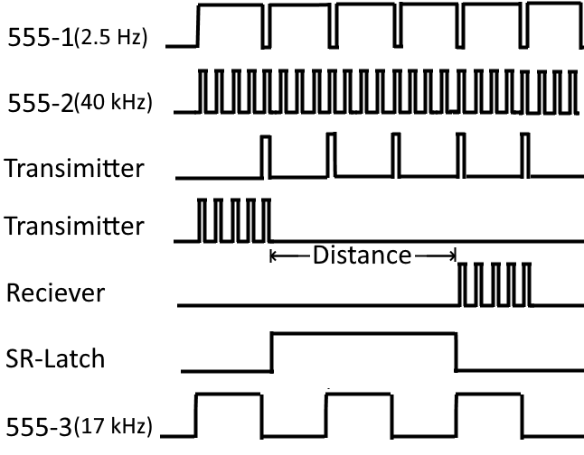

**Figure 2:** Timing diagram of the ultrasonic rangefinder circuit.

**Component list**

The following is a list of components used to build the ultrasonic rangefinder. Some of the integrated circuit chips have multiple instances of a certain circuit on a package. The quantity number indicates how many of packages of each type were used.

Timers:

* TLC555 LinCMOS Timer $×$ 3

Amp stage and comparator:

* LM324 quadruple operational amplifier
* LM311 differential comparator $×$ 1

Counting circuit and display:

* SN74HC161 4-bit synchronous binary counter $×$ 2
* CD74HC4511 BCD-TO-7SD latch/decoder/driver $×$ 2
* VAOS-C402S9-BW50 common-cathode display $×$ 2

Digital logic

* SN74HC00 quadruple 2-input positive-NAND gate $×$ 2
* TC74HC02 quad-input NOR gate $×$ 1

**IMPLEMENTATION**

**Piezoelectric transducer**

Two piezoelectric transducers, placed adjacent to one another, are used to transmit and receive the ultrasonic signals required to measure the time-of-flight to display a distance reading. According to the data sheet of the piezoelectric transducer (Fig. 3), the center frequency was about 40 $±$ 1 kHz. This means that at 40 kHz, the resonant frequency of the transducer crystal is reached, and presents the best frequency response. This was verified by testing the transducers at various frequencies and observing the amplitude of the received signal via the oscilloscope.

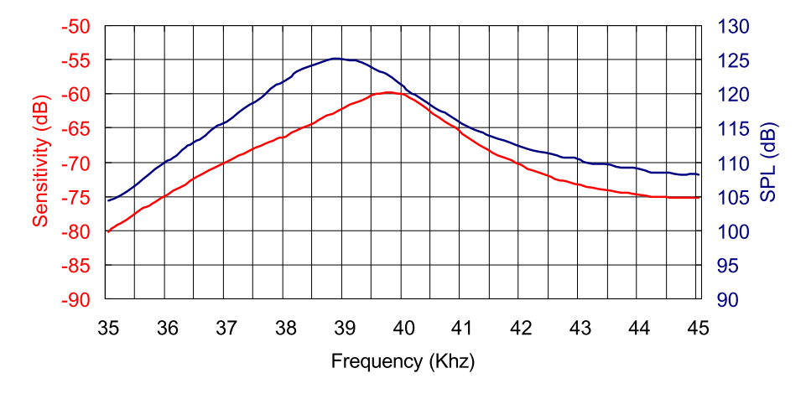

**Figure 3:** Frequency response of a piezoelectric transducer plotted against frequency. Obtained from the data sheet of the transducer.

**Pre-amp stage**

Initially, the design included a pre-amp stage to boost the received signal that would go into the filter. This was done by using an LM324 operational amplifier set up to achieve a gain of 8. Fig. 4 shows the pre-amp used in the design.

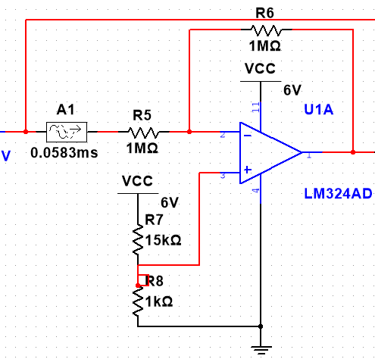

**Figure 4:** *Circuit schematic of pre-amp stage.*

**Filter**

To ensure that a high-quality 40 kHz signal is fed into the comparator, a bandpass filter was used to remove the unwanted noise outside the passband. This filter was a passive second-order bandpass filter. Fig. 5 shows the filter used in the design.

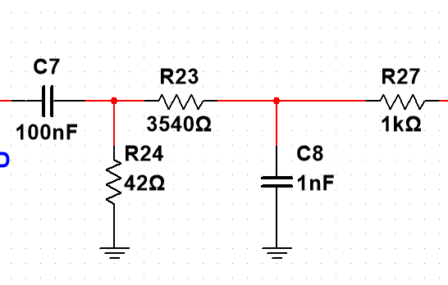

**Figure 5:** *Circuit schematic of passive bandpass filter used in the design.*

The filter had a low frequency cutoff of 38 kHz and a high frequency cutoff of 45 kHz. The following table displays the values used in the design.

|  |  |  |  |
| --- | --- | --- | --- |
| **R1 ± 5% Ω** | **R2 ± 5% kΩ** | **C1 ± 5% nF** | **C2 ± 5% nF** |
| 42 | 3540 | 100 | 1 |

**Amplifier stage**

Similar to the pre-amp stage, another LM358 operation amplifier was placed after the bandpass filter to increase the signal an adequate level for input into the comparator. The amplifier stage was designed to have a gain of 2.67. Fig.6 shows the amplifier used in the design.

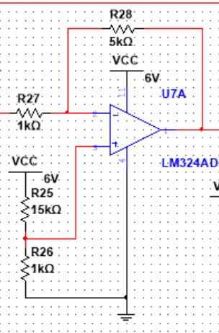

**Figure 6:** *Circuit schematic of amp stage.*

**Comparator**

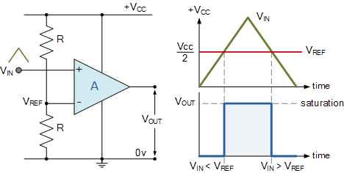

**Figure 7:** Schematic of comparator circuit.

A comparator (Fig. 7) is used to switch to toggle the latch once the ultrasonic signal has been received, transferring the analogue signal to the digital domain so that it can be processed by the counting circuit. Our VREF was 1V, and a signal with a greater voltage than 1V would trigger the comparator to output a signal to toggle the latch. The comparator used was the ‘LM311 differential comparator’ and the potential division to create VREF was achieved with a potentiometer.

**CMOS 555 Timer**

The design of the ultrasonic rangefinder was heavily dependent on regular clock signals of various frequencies. To provide this frequency, a CMOS 555 timer was used. This chip is an example of an astable multivibrator. In this configuration, the 555 timer is simply a two-state oscillators that continually switches between a ‘high’ and ‘low’ state. According to the 555 time data sheet, the ‘high’ state is equivalent to VCC – 2 while the low state had a maximum output of 0.3V.

Fig. 8 shows the configuration of the 555 timer required to set it up in astable mode and provide the clock signal.

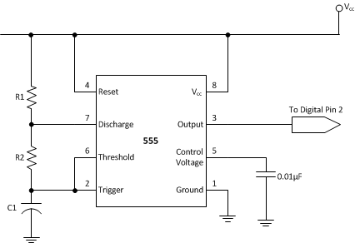

**Figure 8**: pinout and connections for the 555 timer in astable mode.

Our design incorporated the use of 3 555 timers. The circuit configuration of these timers is shown in the table below, and the justification for their design is further explained in the following sections.

Fig. 9 shows the values of R1, R2 and C1 used to achieve the respective target frequencies of each transducer. For convenience, I purchased a set of potentiometers that allowed me to adjust the resistances very carefully until the output frequency of the timers was at the desired value.

|  |  |  |  |  |
| --- | --- | --- | --- | --- |
| Frequency ± 1% (Hz) | C1 ± 1% (nF) | R1 ± 1% (kΩ) | R2 ± 1% (kΩ) | Duty Cycle (%) |
| 17,014 | 1 | 6.8 | 39 | 54 |
| 40,000 | 68 | 100 | 177 | 55 |
| 2.5 | 10 $μ$ F | 1 | 56 | 98.3 |

**Figure 9**: Component values for 555 timers.

**Timer 1**

Our design aimed to design a rangefinder that could continuously refresh the distance reading in a manner similar to a parking sensor in a car. It was necessary to choose an update frequency that would be user-friendly; that is, it updates the reading slow enough so that the user can read it, while providing a reasonably fast response time to track fast changes in the measured distance. After much trial and error, we decided to use a 2.5Hz timer.

This timer also provided a second functionality: it was used as an ‘envelope’ for the window of sending out the ultrasonic pulse. To achieve this, we designed a timer with a very high duty cycle of 95%. Using a NOT gate, the ‘low’ component of the cycle of this timer would trigger both the sending of the ultrasonic pulse and the start of the counter circuit, as well as resetting the previous value stored by the S-R latch. As such, the timer had an ‘off’ time of

$$\frac{1}{3}sec×90\%$$

which is equal to 0.03 seconds. It was important to ensure that this ‘pulse envelope’ was not shorter than the time it took for the counter to count to 99. With a counting timer frequency of 17,015 Hz (explained in the **Timer 3** section below), it took 6ms to count from 0 to 99.

**Timer 2 (40 kHz)**

A 555 timer (Timer 2) was used to provide the input for the ultrasonic signal fed into the probing piezoelectric transducer. Using the known centre frequency of 40 kHz from the piezoelectric transducer data sheet, the timer was set up in the configuration shown in Fig. 6.

**Timer 3 (17 kHz)**

The counter circuit is driven by a CMOS 555 timer (Timer 3) in astable mode to provide a consistent square wave input i.e. a clock input akin to that of a function generator. The clock frequency of the timer was carefully chosen such that 1 clock cycle of the timer would correspond to 1 centimeter on the display. This was determined by using the known speed of sound in air, resulting in the following calculations to determine the time taken for sound to travel 1cm:

$$V_{s}=340.27 ms^{-1}$$

Using the following relation, the time taken for sound to travel 1cm can be determined:

$$frequency=\frac{speed}{distance}$$

$$34027=\frac{340.27 ms^{-1}}{1 cm}$$

The clock frequency of the 555 timer is determined to be 34,027 Hz, meaning that it counts up additional centimeter of distance travelled by the signal (in a straight-line distance) for every clock cycle. However, noting that in practice the ultrasonic signal must travel the distance to the object being measured and then be reflected back to the transducer, the distance travelled by the signal, and thus the time of flight, is in fact double the distance being measured. It is necessary to divide the frequency by 2 to compensate for this so it counts half as fast and displays half the distance travelled in total by the signal. The actual clock frequency necessary to drive the synchronous counter circuit is therefore

$$f=17014 Hz$$

**Synchronous counter circuit**

At the heart of the rangefinder is the counter circuit. This is used to count the time between sending the ultrasonic signal and for it to be received and processed through the comparator circuit. The counter circuits is composed of two synchronous 4-bit counters (74HC161) that each feed into a 7-segment-display via a BCD-to-7-segment decoder (74HC4511). The synchronous 4-bit counter was chosen to avoid lag/delays due to transistor slew rates from cascading and propagating throughout the clock cycles, which could potentially be an issue due to the high frequency of the clock.

The output 4-bit counter represents a single decimal digit, which is fed into the binary decoder/ 7-segment-display driver (74HC11). As the counter chip counts from 00002 to 11112 (0 to 16 in base 10), additional logic is needed to ensure that the chip resets to 0 once it has reached 9. This is achieved by noting that the binary representation of 1010 is 1010. Then, the QB­­ and QD outputs of the counter are connected to the inputs of a NAND gate whose output is tied to the active-low RESET pin of the 4-bit counter chip. When QB­­ and QD output ‘high’, the NAND gate outputs ‘low’, and the active-low RESET pin resets the timer.

The counter that represents the 4 least-significant-bits is driven by Timer 3 (17 kHz) and the counter representing the 4 most-significant-bits is clocked by the output of the NAND gate that controls the reset of the 4-LSB counter.

**S-R Latch**

Once the ultrasonic signal has been received and the comparator has been activated, the circuit must be able to ‘stop’ the counter and ‘hold’ the value it has counted up for the reader to view. The number it stops at is effectively the value of the distance between the transducer and the object in question.

To accomplish this, an S-R latch is used. This is an example of a bistable multivibrator. These two states are known as ‘set’ and ‘reset’, and an S-R latch can be created from two NAND gates in the following configuration:

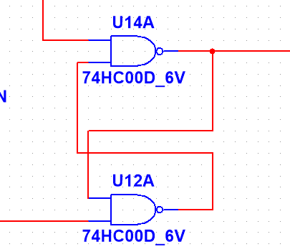

**Figure 10**: Schematic of S-R latch.

Fig. 11 shows the truth table of an S-R latch. The output of the comparator makes the latch toggle between Q and $\overline{Q}$.

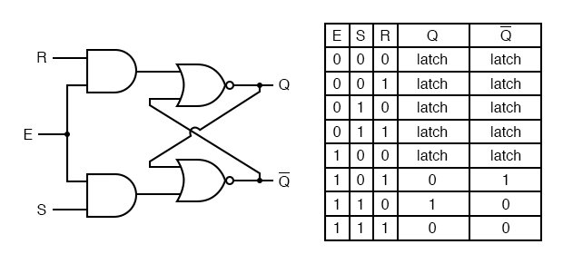

**Figure 11**: Truth table of S-R latch.

**TESTING AND RESULTS**

When testing the ultrasonic rangefinder, it was found that it behaved abnormally and could not produce a reliable distance reading. The main observation was that when an object was placed a distance away, the rangefinder would show an arbitrary number (indicating that the latch was performing as intended) every 0.4 seconds (the period of the 2.5Hz timer).

When building the circuit, we came upon issues getting the bandpass filter to work with the amplifier. It was found that for some reason when using the filter alongside the amplifier, the amplifier could not generate the necessary gain needed to activate the comparator. We were not able to find a solution to this problem, and therefore removed the filter from the breadboard. The resulting signal was noisy, but we found that it nonetheless performed adequately in triggering the amplifier.

The pre-amp stage was also cut from the implementation as it was also causing issues with the other components in the receiving stage. The need for one was bypassed by using the power supply to output a 12V signal solely into Timer 1 which produced a significantly more powerful (10V pk-pk) ultrasonic signal.

Nevertheless, we used the oscilloscope to measure the performance of the individual components to try and find the cause of the problem. As a result of our testing, we were able to discern the activity of each component at a certain point in time.

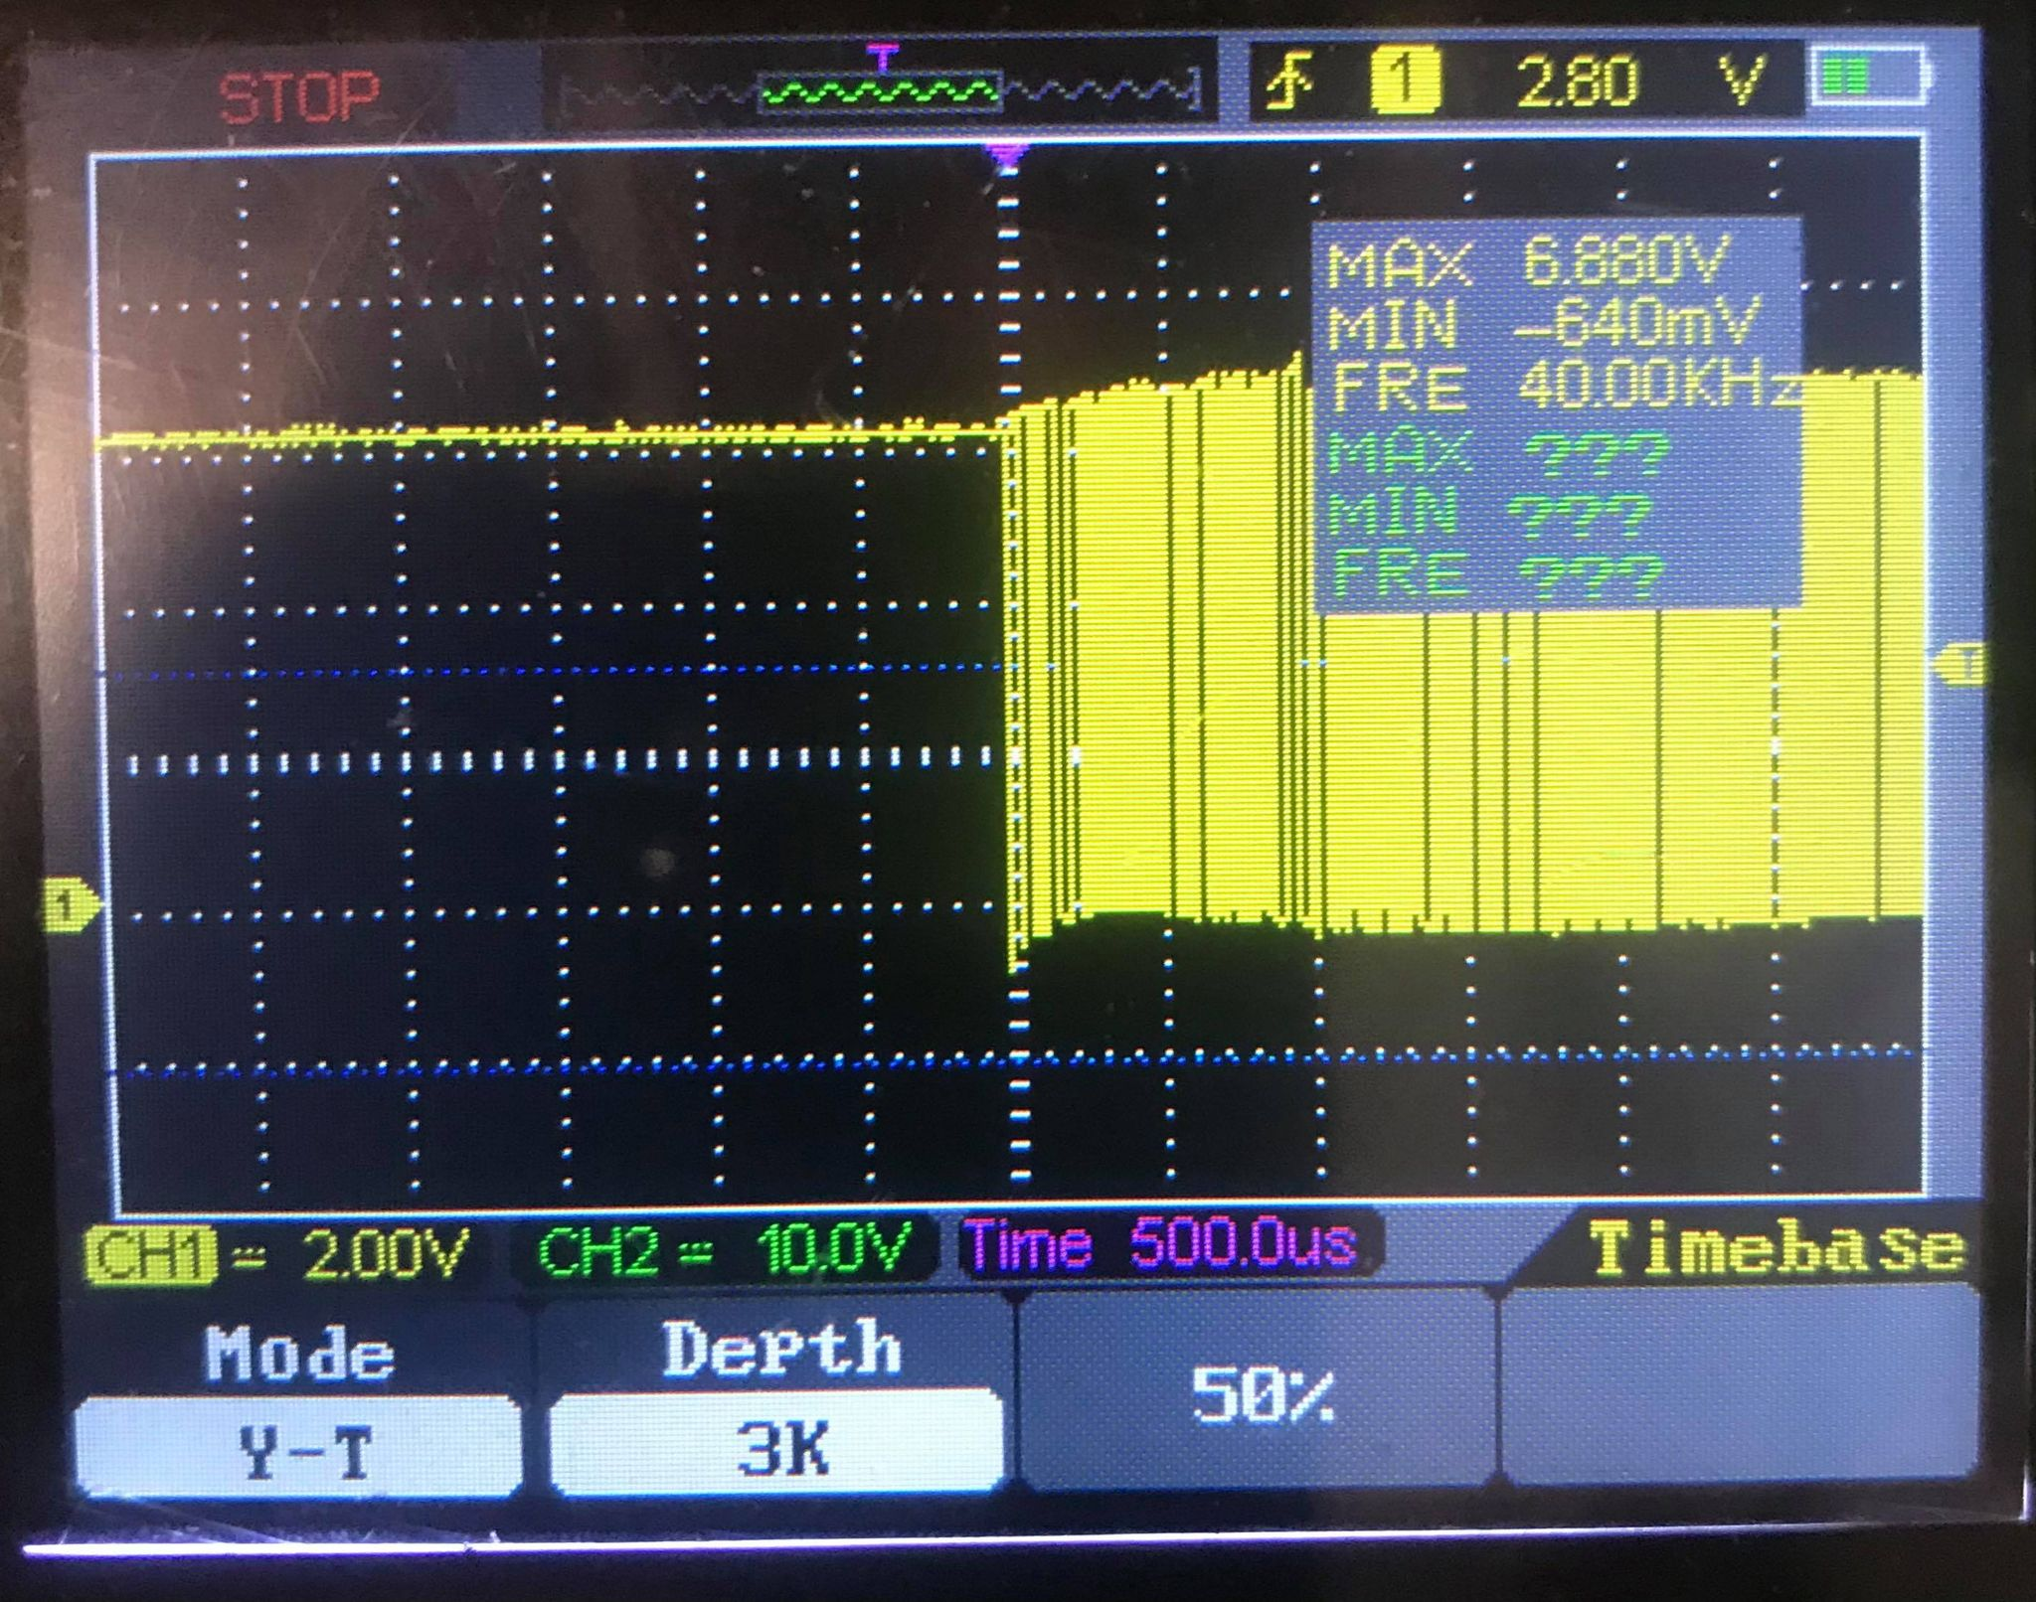

**Figure 12**: *Oscilloscope output showing NAND gate output.*

Fig. 12 shows the NAND gate output. This visualization is useful as it shows the effect of both the pulse envelope and the 40 kHz signal generated by Timer 1. As shown on the oscilloscope, Timer 1 was able to feed a steady precise 40 kHz signal into the piezoelectric transducer.

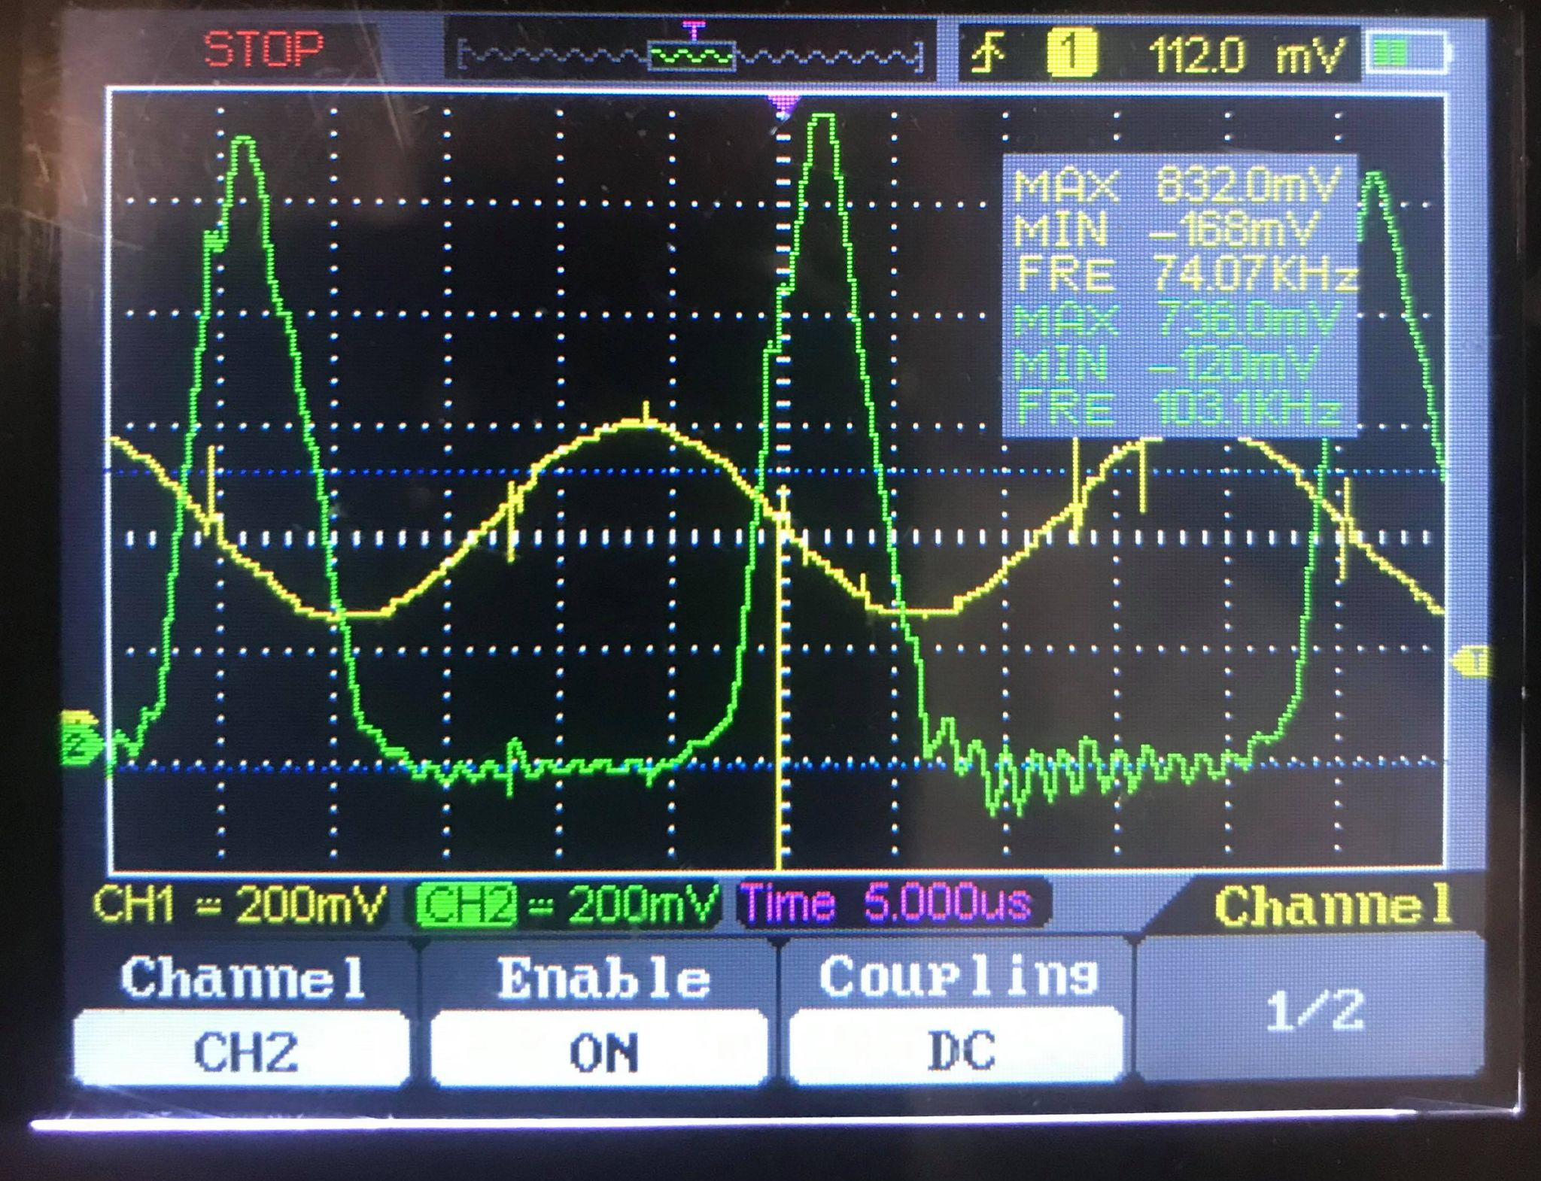

**Figure 13**: *Oscilloscope output showing amplified (green) vs. default (yellow) signal.*

Fig. 13 shows the amplifier output against the input signal generated by Timer 2. Visually, the op amp appears to be amplifying the signal well, albeit with some clipping at the lower portion as well as a slight phase shift that represents the time-of-flight.

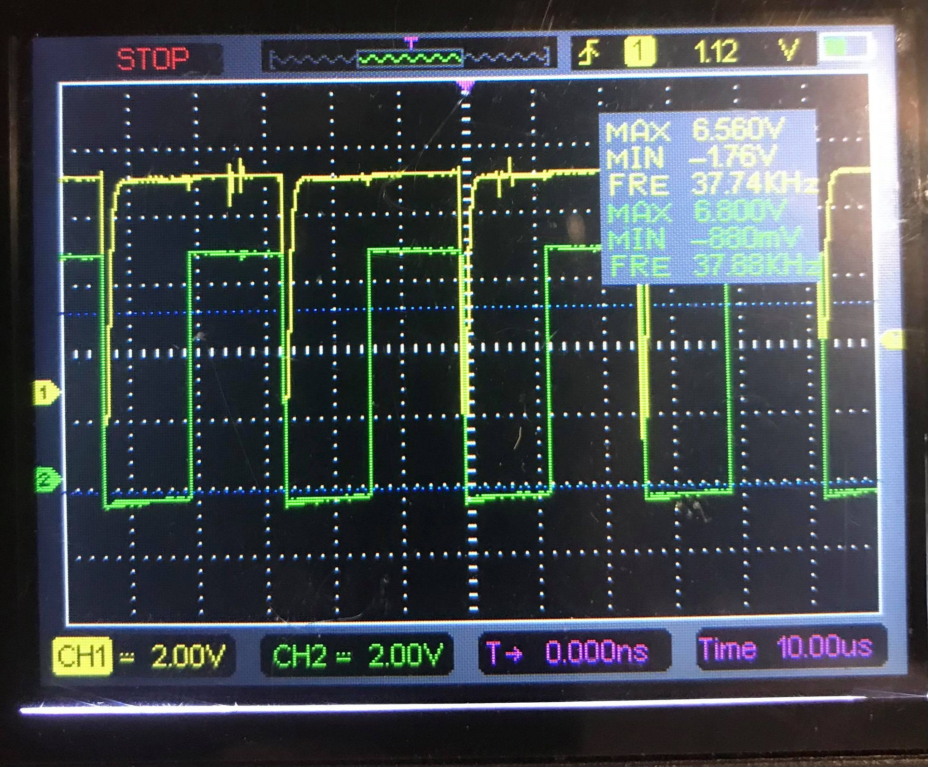

**Figure 14**: *Oscilloscope output showing latch (green) and comparator (yellow) signal.*

Fig. 14 shows the comparator and the latch output from the oscilloscope. The comparator appears to activate properly when receiving a signal from the amplifier, and the latch likewise appears to toggle as intended as well.

**DISCUSSION & CONCLUSION**

The individual component testing and the screenshots indicate that the individual components specified in the block diagram (Fig. 1) do function as intended.

However, when testing the ultrasonic rangefinder, it was found that it behaved abnormally and could not produce a reliable distance reading. The main observation was that when an object was placed a distance away, the rangefinder would show an arbitrary number (indicating that the latch was performing as intended) every 0.4 seconds (the period of the 2.5Hz timer).

Our testing leads us to infer that the actual breadboard implementation of the rangefinder was very close to being fully functional. An explanation for the ‘pause-and-count’ behavior that was observed could stem from a simple oversight: the output of the latch was not connected to the reset pins of the counters, and therefore the counters would simply carry on counting once the latch toggled back to its ‘off’ state. Indeed, once that connection had been fixed after the presentation, the rangefinder was able to produce much more sensible distance readings.

Although the rangefinder was not able to produce the required functionality during the presentation, the testing demonstrates that in a vacuum, each of the target techniques specified in the ‘Introduction’ were satisfied. The amplification of the low-level signal was sufficient to reliably trigger the comparator without excessive noise; the counting circuit functioned perfectly (as observed with driven with a low-frequency signal); and the results, although inaccurate, were clearly and logically presented on the digital display. As a result, it can be concluded that the high-level design from the block diagram, the detailed design in the circuit schematic and the majority of the breadboard implementation were all successful in the scheme and objectives of this project.

**Appendix I**

* 1. Circuit diagram

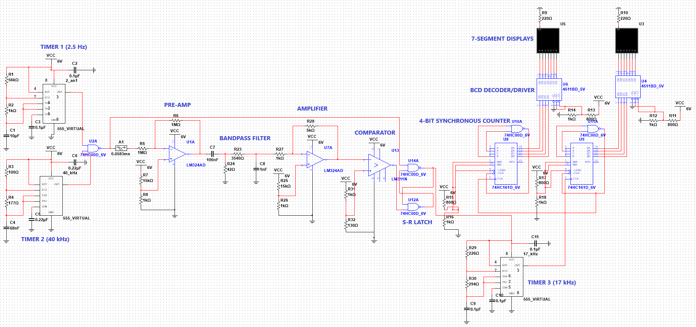

**Appendix II**

**2.1** Piezoelectric transducers

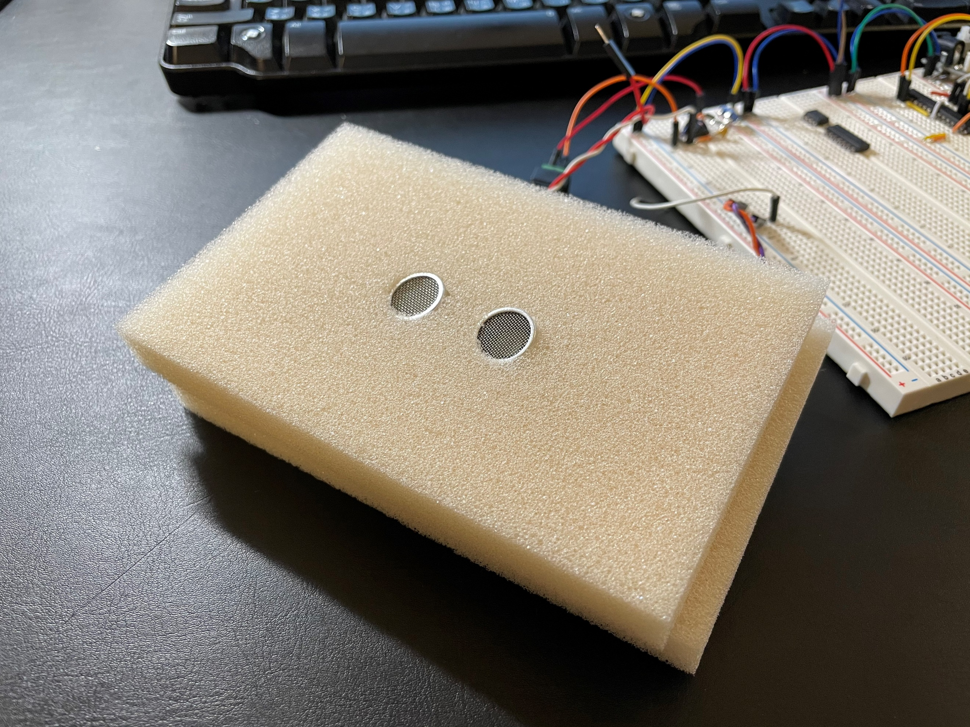

**2.2** Circuit layout

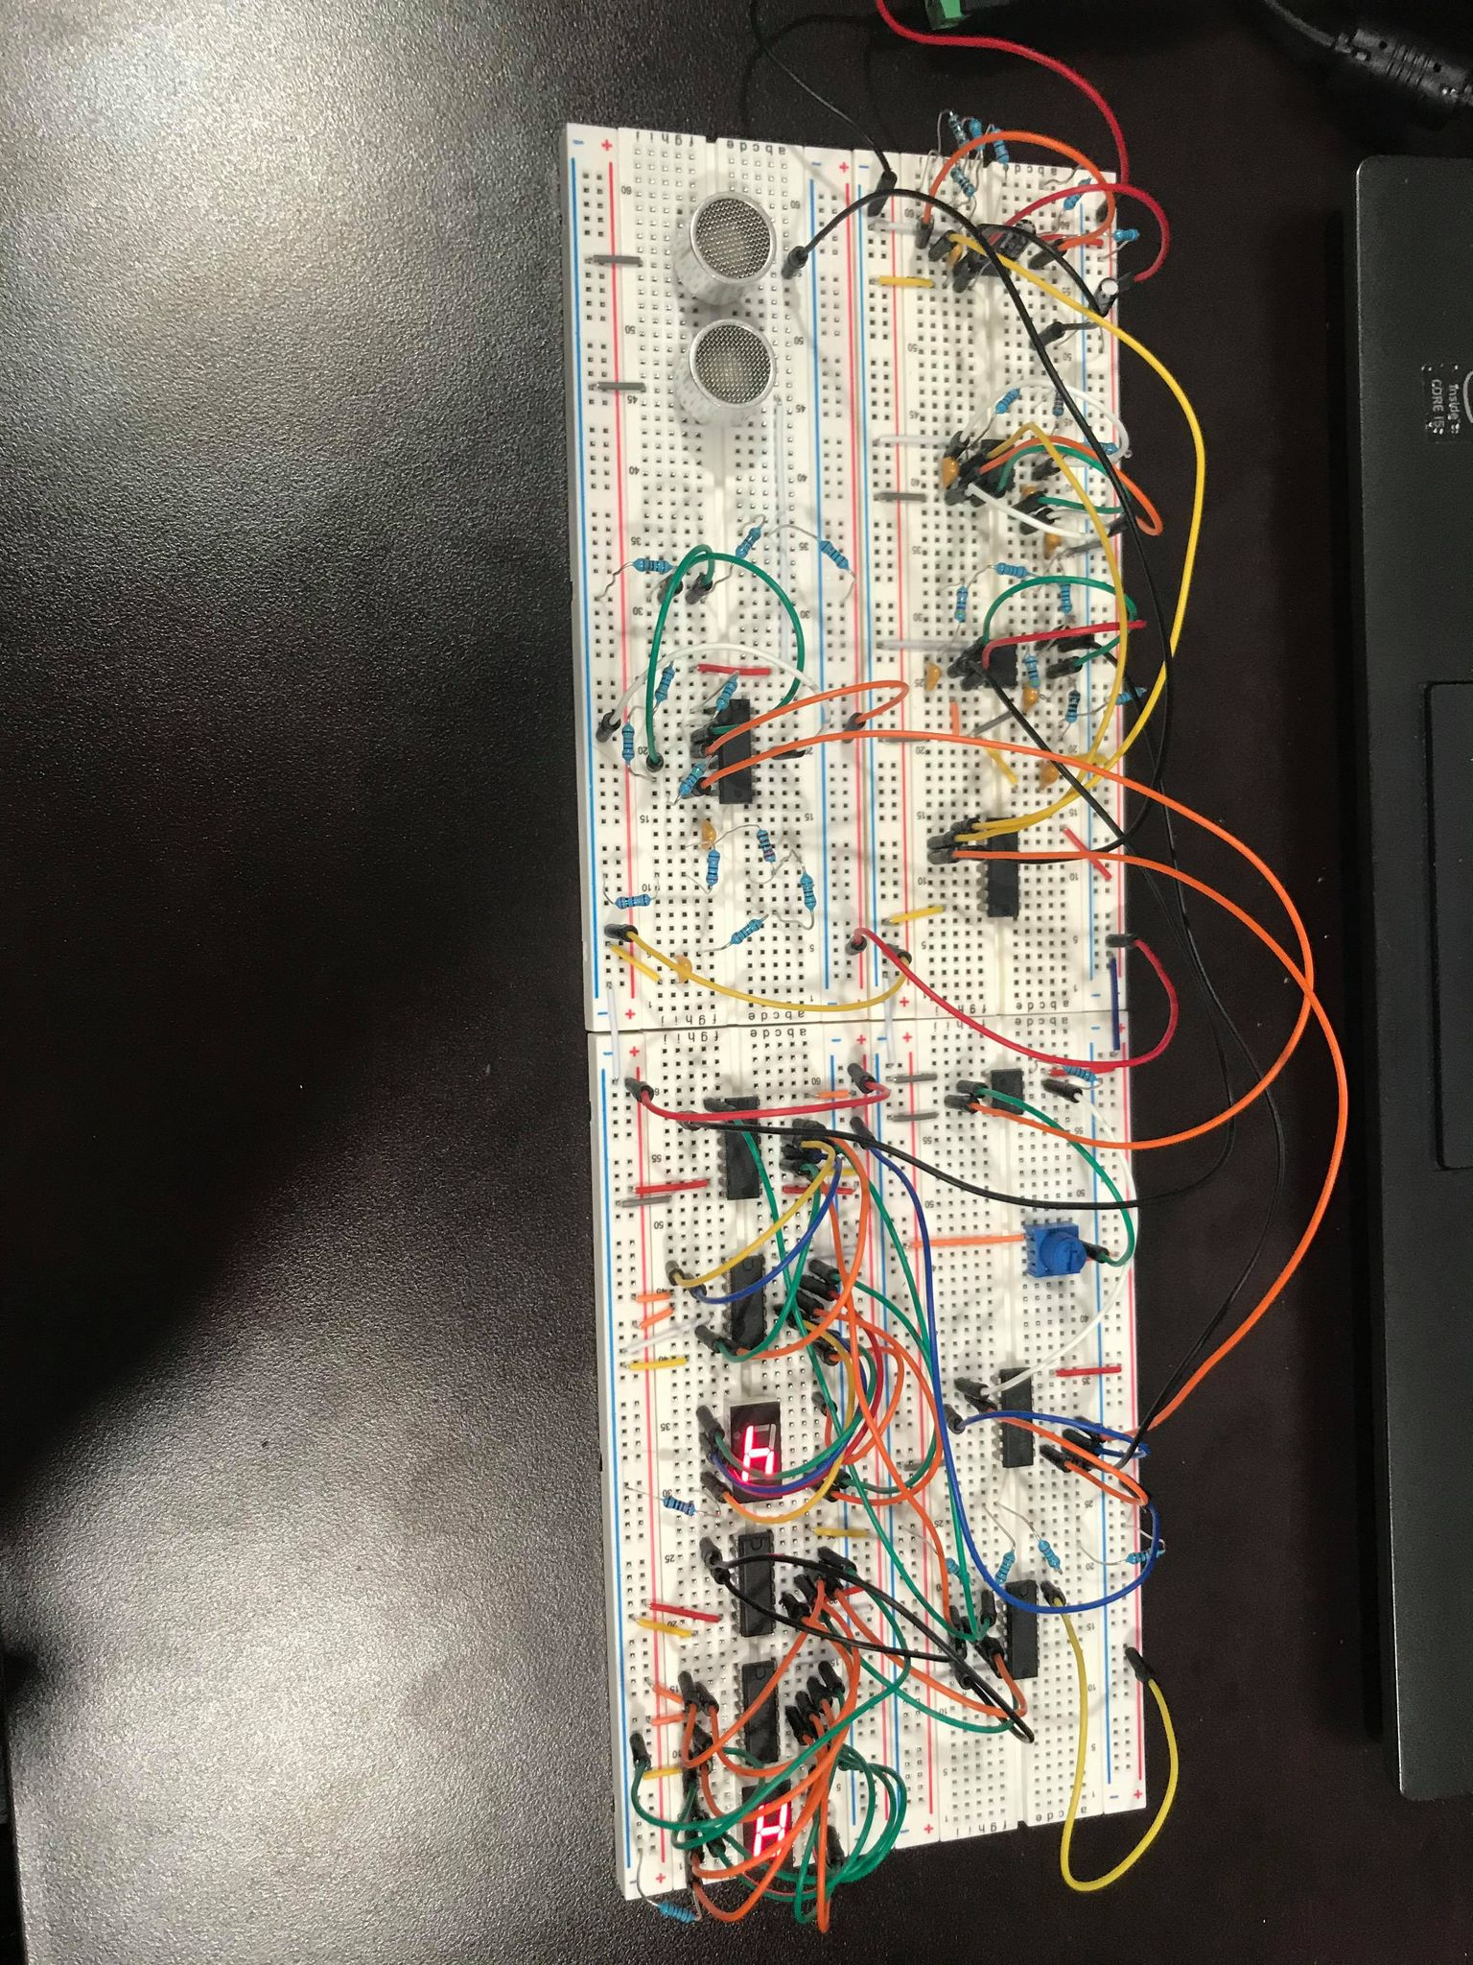

**2.3** Counting circuit, BCD chip, decoder and 7-segment display

